**Christopher Peng**

**Exercise 2:** What’s wrong with these two visualizations and how would you fix them or revisualize them?

### First Visualization (Scatter Plot: "OFC. Super Deluxe - 8/11/16 - Top PvP by Platform")

1. **Lack of Axes Labels**:
   * There are no labels for the x-axis or y-axis, making it unclear what the points represent.
   * **Fix**: Add descriptive labels for both axes (e.g., x-axis could represent player ID or match ID, and y-axis could represent match scores or another meaningful metric).
2. **Overplotting**:
   * The data points appear clustered and cluttered at the lower values, making it hard to distinguish individual points and interpret the density of data.
   * **Fix**: Consider adding transparency (alpha) to the points so overlapping areas become more apparent. Alternatively, you could use a heatmap or density plot to visualize regions where many points overlap.
3. **Outliers**:
   * The presence of extreme outliers (points at or above 30,000 on the y-axis) distorts the visualization of the rest of the data, which mainly hovers between 0 and 5000.
   * **Fix**: Consider using a logarithmic scale for the y-axis to better manage the range and visualize both the outliers and the main dataset. You could also highlight or annotate the outliers to explain their significance.
4. **Legend Issue**:
   * The legend only shows "Series2," which is unclear and uninformative.
   * **Fix**: Rename the series to something more descriptive, such as the platform or match type being visualized.

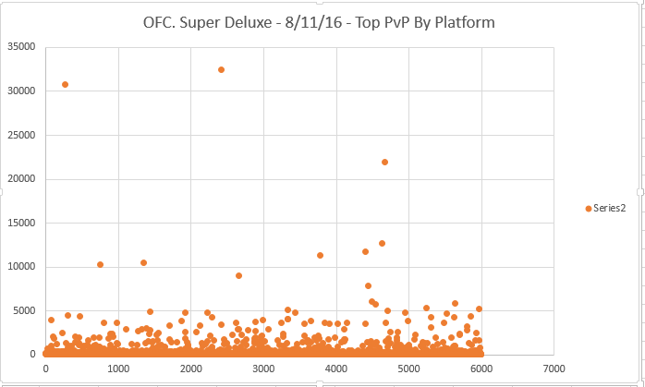

### Second Visualization (World Map: "Hofstede - Individualism Scores")

1. **Unclear Color Legend**:
   * The color legend is vague and hard to interpret without detailed context. For example, it’s unclear what the colors signify regarding the meaning of individualism scores.
   * **Fix**: Provide more context on the meaning of each score range and how individualism is defined in this context. This could be done by adding tooltips or annotations explaining the relevance of high and low scores.
2. **Color Scheme**:
   * The color scheme is not intuitive and can be problematic for color-blind users. The red, green, and yellow hues can be difficult to distinguish for those with color vision deficiencies.
   * **Fix**: Use a more color-blind-friendly palette or a gradient scale (e.g., from light to dark shades of a single color) to represent the individualism scores. Also, ensure there's enough contrast between regions to make differences more visible.
3. **Map Scale**:
   * The map has a large empty gray region for countries with missing data, which might mislead the viewer into assuming those countries are part of the dataset.
   * **Fix**: If data is not available for certain regions, consider using a more neutral or subdued color (like light gray or white) to signify that information is missing. This avoids confusion with regions that have low scores.
4. **Country Codes**:
   * The map only uses color to differentiate between countries, which can be insufficient if the viewer isn't familiar with world geography.
   * **Fix**: Add hover tooltips or labels that show the country name and the exact individualism score. This would provide clearer insight without requiring users to guess.

1. Poor color scale
2. Values do not encompass entire range
3. Inconsistent data range
4. Order of legend
5. 50% threshold (most important for this dimension of culture) is obscured

### Summary of Improvements:

* **Scatter Plot**:
  + Add axis labels.
  + Use transparency or density plots to manage overplotting.
  + Handle outliers with a log scale or by annotating them.
  + Fix the legend to be more descriptive.
* **Map**:
  + Improve the clarity of the legend.
  + Use a color-blind-friendly palette.
  + Adjust the color scale for missing data.
  + Add tooltips or labels for each country to make the data more accessible.

These changes would make both visualizations more informative and user-friendly.